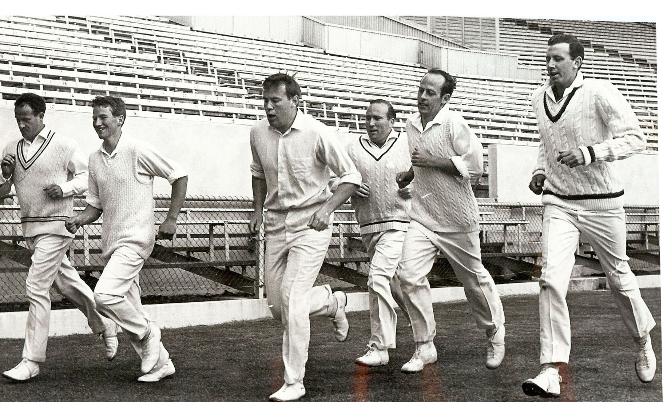

Canterbury Cricket Squad Pre Season Training Lancaster Park October 1968

**From left**: JM McIntyre, JD Riley, RW Anderson, NA Huxford, BF Hastings, BR Taylor